

**Data Base Management Project**

Hotel Reservation System

Subject

3.1 Introduction

3.2 System workflow

3.3 ER Diagram

3.4 Schema

3.5 DDL-SQL & INSERT RECORD

3.6 System Architecture

3.7 System Forms

Teams

1.Ahmed Fahad Abu-Hamdah

2.Chukwuma Mishael Chinomso

**3.1 Introduction**

the project presentation our Hotel Reservation System, developed as part of our course in Database Management. In this project, we embarked on the task of designing and implementing a comprehensive system to streamline hotel operations and facilitate efficient booking processes.

The hospitality industry relies heavily on efficient management systems to handle reservations, guest information, room allocation, and administrative tasks. Our aim was to create a robust and user-friendly database management system that caters to the needs of both hotel administrators and guests.

**3.2 System workflow**

***Workflow:***

* + Guest requests a room reservation from a staff member (either in person, via phone, or through other communication channels).
  + The staff member checks the availability of rooms based on the guest's requirements (dates, room type, etc.).
  + If a suitable room is available, the staff member selects a room from the available options.
  + The staff member collects necessary guest information (name, contact details, etc.) if not already available.
  + The staff member creates a new reservation record in the database, associating the guest, staff member, and selected room.
  + The reservation record is updated with relevant dates (reservation, check-in, and check-out).
  + Confirmation details (reservation ID, room details, dates, etc.) are provided to the guest.
  + every room can have an Amenities.
  + The billing associating with user based on room Reservation.
  + Guest can write a Review about the Reservation

**3.3 ER Diagram**

**3.4 Schema**

**Review**

|  |  |  |
| --- | --- | --- |
| Review Comment | Review ID | Review Rating |

**Guest**

|  |  |  |  |  |  |  |  |
| --- | --- | --- | --- | --- | --- | --- | --- |
| Guest ID | Guest SSN | Guest FirstName | Guest LastName | Guest Nationality | Guest Phone | Guest Email | Guest Age |

**Bill**

|  |  |  |  |  |
| --- | --- | --- | --- | --- |
| Bill ID | Bill Total-Amount | Bill Payment-Method | Bill Payment-Status | Guest No |

**Staff**

|  |  |  |  |  |  |
| --- | --- | --- | --- | --- | --- |
| Staff ID | Staff FirstName | Staff LastName | Staff Phone | Staff Email | Staff Position |

**Reservation**

|  |  |  |  |  |  |  |
| --- | --- | --- | --- | --- | --- | --- |
| Staff ID | Guest SSN | Reserve ID | Reservation CheckOutDate | Reservation CheckInDate | Reserve Amount | Room No |

**Room**

|  |  |  |  |  |
| --- | --- | --- | --- | --- |
| Room Number | Room Availability | Room Type | Room Floor | Room Price |

**Amenities**

|  |  |  |  |
| --- | --- | --- | --- |
| Amenities ID | Amenities Name | Amenities Number | Amenities Description |

**3.5 DDL-SQL & INSERT Record**

CREATE TABLE guest  
(  
 guest_id NUMBER(38, 0) NOT NULL,  
 name VARCHAR2(255) NOT NULL,  
 ssn VARCHAR2(255) NOT NULL,  
 phone_number VARCHAR2(255),  
 age INTEGER,  
 email VARCHAR2(255),  
 CONSTRAINT pk_guest PRIMARY KEY (guest_id)  
);  
  
ALTER TABLE guest  
 ADD CONSTRAINT uc_guest_phone_number UNIQUE (phone_number);  
  
ALTER TABLE guest  
 ADD CONSTRAINT uc_guest_ssn UNIQUE (ssn);  
  
*-----------------------------------------------------------------------*CREATE TABLE amenities  
(  
 id NUMBER(38, 0) NOT NULL,  
 name VARCHAR2(255),  
 desciption VARCHAR2(255),  
 room_id NUMBER(38, 0),  
 CONSTRAINT pk_amenities PRIMARY KEY (id)  
);  
  
ALTER TABLE amenities  
 ADD CONSTRAINT FK_AMENITIES_ON_ROOM FOREIGN KEY (room_id) REFERENCES room (id);  
  
*-----------------------------------------------------------------------*CREATE TABLE bill  
(  
 id NUMBER(38, 0) NOT NULL,  
 guest_guest_id NUMBER(38, 0),  
 total_amount VARCHAR2(255),  
 payment_method VARCHAR2(255),  
 payment_status VARCHAR2(255),  
 CONSTRAINT pk_bill PRIMARY KEY (id)  
);  
  
ALTER TABLE bill  
 ADD CONSTRAINT uc_bill_guest_guest UNIQUE (guest_guest_id);  
  
ALTER TABLE bill  
 ADD CONSTRAINT FK_BILL_ON_GUEST_GUEST FOREIGN KEY (guest_guest_id) REFERENCES guest (guest_id);  
  
*-----------------------------------------------------------------------*CREATE TABLE reservation  
(  
 id NUMBER(38, 0) NOT NULL,  
 check_i_out_date date NOT NULL,  
 check_in_date date NOT NULL,  
 guest_guest_id NUMBER(38, 0),  
 staff_id NUMBER(38, 0),  
 room_id NUMBER(38, 0),  
 CONSTRAINT pk_reservation PRIMARY KEY (id)  
);  
  
ALTER TABLE reservation  
 ADD CONSTRAINT uc_reservation_room UNIQUE (room_id);  
  
ALTER TABLE reservation  
 ADD CONSTRAINT FK_RESERVATION_ON_GUEST_GUEST FOREIGN KEY (guest_guest_id) REFERENCES guest (guest_id);  
  
ALTER TABLE reservation  
 ADD CONSTRAINT FK_RESERVATION_ON_ROOM FOREIGN KEY (room_id) REFERENCES room (id);  
  
ALTER TABLE reservation  
 ADD CONSTRAINT FK_RESERVATION_ON_STAFF FOREIGN KEY (staff_id) REFERENCES staff (id);  
  
*-----------------------------------------------------------------------*CREATE TABLE review  
(  
 id NUMBER(38, 0) NOT NULL,  
 rating INTEGER NOT NULL,  
 comment VARCHAR2(255),  
 guest_guest_id NUMBER(38, 0),  
 CONSTRAINT pk_review PRIMARY KEY (id)  
);  
  
ALTER TABLE review  
 ADD CONSTRAINT FK_REVIEW_ON_GUEST_GUEST FOREIGN KEY (guest_guest_id) REFERENCES guest (guest_id);  
  
*-----------------------------------------------------------------------*CREATE TABLE room  
(  
 id NUMBER(38, 0) NOT NULL,  
 availability NUMBER(1),  
 floor VARCHAR2(255),  
 type VARCHAR2(255),  
 price DOUBLE PRECISION,  
 CONSTRAINT pk_room PRIMARY KEY (id)  
);  
*-----------------------------------------------------------------------*CREATE TABLE staff  
(  
 id NUMBER(38, 0) NOT NULL,  
 name VARCHAR2(255),  
 phone VARCHAR2(255),  
 position VARCHAR2(255),  
 email VARCHAR2(255),  
 CONSTRAINT pk_staff PRIMARY KEY (id)  
);

*-----------------------------------------------------------------------*

INSERT INTO guest (name, ssn, phone_number, age, email)  
VALUES  
 ('John Doe', '123-45-6789', '123-456-7890', 35, 'john@example.com'),  
 ('Jane Smith', '987-65-4321', '987-654-3210', 28, 'jane@example.com'),  
 ('Sam Wilson', '567-89-0123', '567-890-1234', 42, 'sam@example.com');  
  
  
INSERT INTO bill (id, guest_guest_id, total_amount, payment_method, payment_status)  
VALUES  
 (301, 1, '250.00', 'Credit Card', 'Paid'),  
 (302, 2, '180.50', 'Cash', 'Pending'),  
 (303, 3, '500.25', 'Debit Card', 'Paid');  
  
  
INSERT INTO staff (id, name, phone, position, email)  
VALUES  
 (101, 'Emily Johnson', '111-222-3333', 'Manager', 'emily@example.com'),  
 (102, 'Michael Brown', '444-555-6666', 'Receptionist', 'michael@example.com'),  
 (103, 'Sarah Davis', '777-888-9999', 'Housekeeping', 'sarah@example.com');  
  
  
INSERT INTO review (id, rating, comment, guest_guest_id)  
VALUES  
 (501, 4, 'Great service!', 1),  
 (502, 5, 'Amazing experience!', 2),  
 (503, 3, 'Room could be cleaner.', 3);  
  
INSERT INTO room (id, availability, floor, type, price)  
VALUES  
 (201, 1, '1st Floor', 'Standard', 99.99),  
 (202, 1, '2nd Floor', 'Deluxe', 149.99),  
 (203, 1, '3rd Floor', 'Suite', 249.99);  
  
INSERT INTO reservation (id, check_i_out_date, check_in_date, guest_guest_id, staff_id, room_id)  
VALUES  
 (401, '2023-01-15', '2023-01-10', 1, 101, 201),  
 (402, '2023-02-20', '2023-02-15', 2, 102, 202),  
 (403, '2023-03-25', '2023-03-20', 3, 103, 203);  
  
INSERT INTO amenities (name, desciption, room_id)  
VALUES  
 ('WiFi', 'High-speed internet access', 201),  
 ('Gym', 'Fitness facilities available', 202),  
 ('Pool', 'Outdoor swimming pool', 203);

**3.6 System Architecture**

**3.7 System Forms**

In our System we have two forms on to register new Guest

And the other forms for reservations

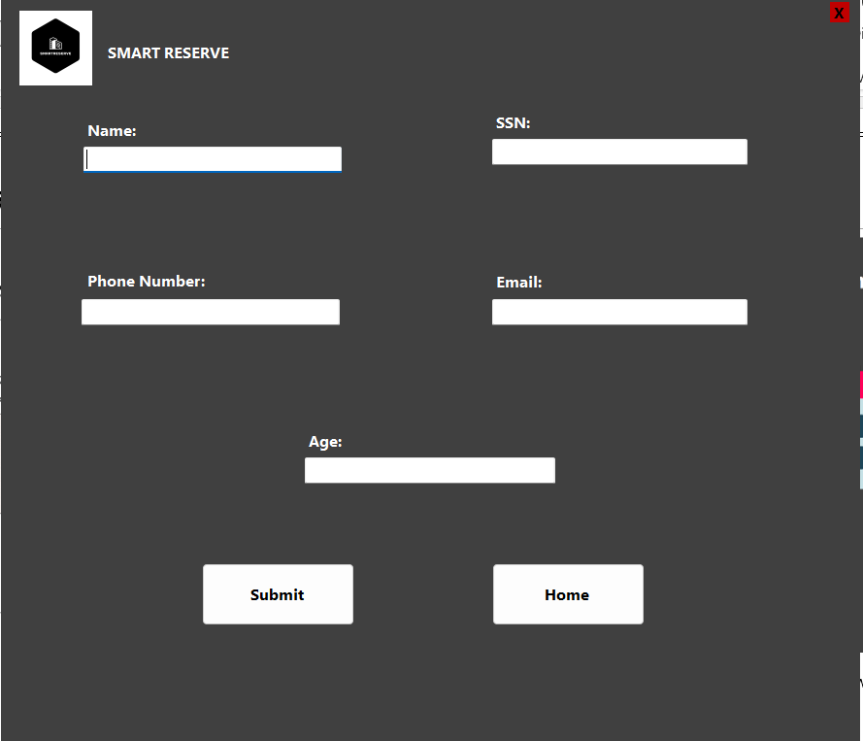

Here you can see the information need it for register new guest

The information stored in the data base.

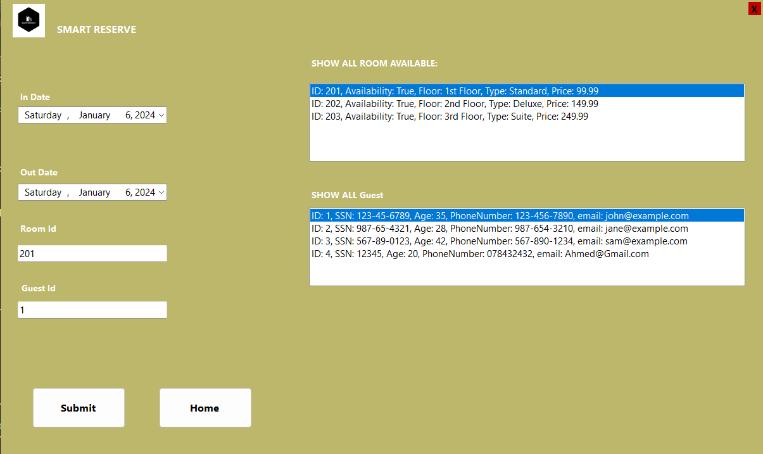

In the reservation forms

You can create a reservation by selecting the check in and check out

And select the rooms available and the guest reservation.